1. You are the sole electrical engineer at a large parking lot conglomerate. Management has dictated that the new “parking spot available” sensors installed need to be interconnected so they return the location of the closest available parking spot to the driver. The sensors output a “1” when the spot is available, and otherwise a “0”.

A sign has been purchased that takes the binary address of one of eight parking spots and displays it on a map for the driver. The binary address of each parking spot is given according to its distance from the driver. 111 should be the closest spot and 000 should be the furthest spot. Use a CD4532 priority encoder to feed the data to the sign.

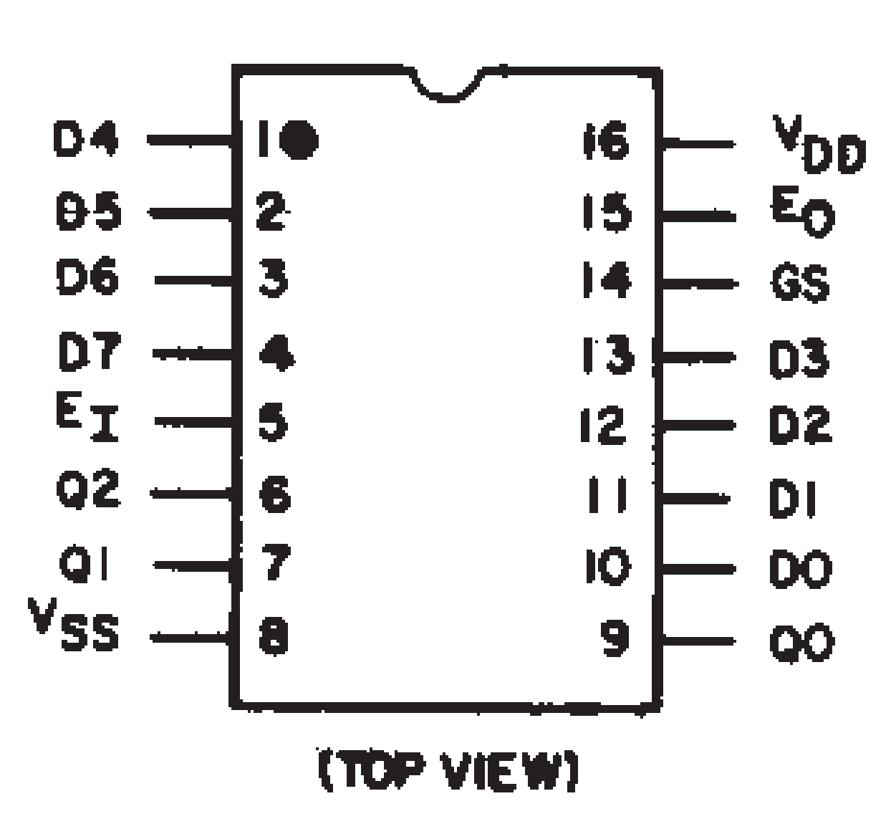 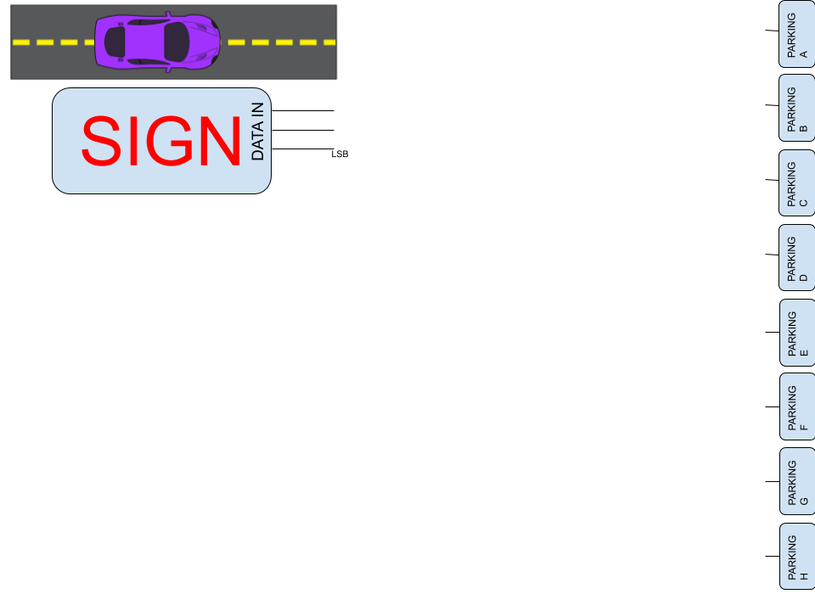



1. 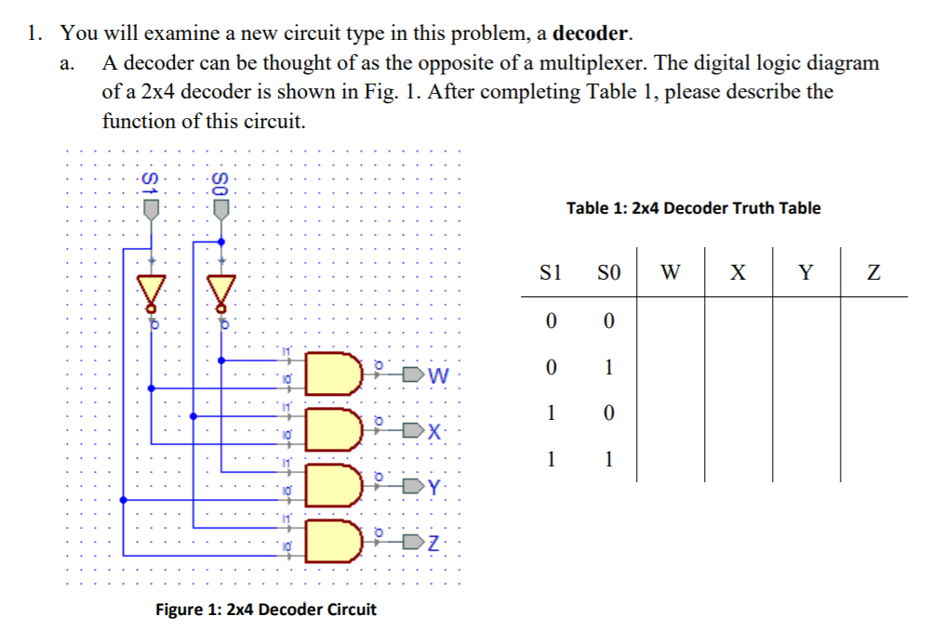



* 1. Complete the truth table and describe the function of the circuit.
     1. Takes S1 and S0 and activates one output based on that address
  2. How does this decoder differ from a demultiplexer?
     1. Decoder has signal lines and outputs, demux has input, signal lines, and outputs
  3. Demonstrate how a CD4051 could be used as this circuit (a 4-output decoder). Map W, X, Y, Z, S0, and S1 to the correct pins on the CD4051.
     1. Set input line on demux to high

1. Your job is to connect transmit data from 8 earthquake sensors from one side of a building to another. The sensors output a “1” after seismic activity passes a certain threshold. Unfortunately, the earthquake-sensor department has totally run out of money and we only have enough cable to have four wires going across our building. How can we make all the data accessible with only four wires? It doesn’t all need to be accessible at the same time, but there should still be 8 separate outputs on the other side of the building.

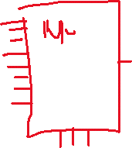

|  |  |  |  |
| --- | --- | --- | --- |
| X | Y | Z | **OUT** |
| 0 | 0 | 0 | **1** |
| 0 | 0 | 1 | **0** |
| 0 | 1 | 0 | **0** |
| 0 | 1 | 1 | **0** |
| 1 | 0 | 0 | **1** |
| 1 | 0 | 1 | **1** |
| 1 | 1 | 0 | **0** |
| 1 | 1 | 1 | **1** |

1. Implement the truth table below using one CD4051 demultiplexer.

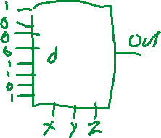

5. At a water processing facility, there are 16 chlorine monitoring sensors at different stages of the purification process. These sensors are **not** digital! They output an analog signal between 0V and 5V. The monitoring computer needs to check in on these sensors occasionally, and while it has a ton of free digital output pins available (say, 75), it only has one analog input pin remaining.

Draw a system using CD4051(s) that will allow the computer to access the data from any given sensor it chooses.

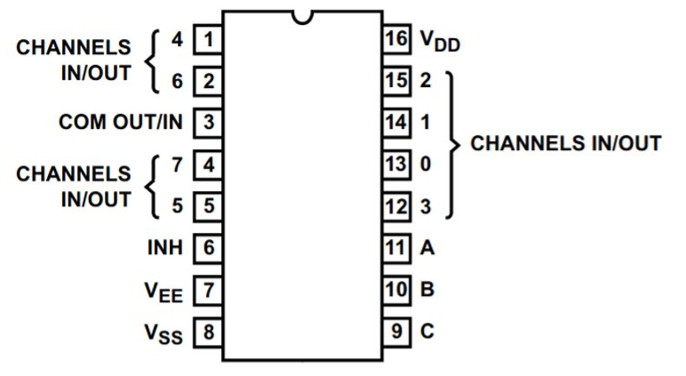







|  |
| --- |
| **6. DO BY SUNDAY NIGHT: Draw your color code project logic using demultiplexers. Do at least one output, but preferably all three. Don’t worry, this shouldn’t take too long!** |

